**DEFINING THE ROLE OF OPERATIONAL SEX RATIO IN FITNESS OF ORGANISMS WITH SEXUALLY ANTAGONISTIC TRAITS**

An Undergraduate Research Scholars Thesis

by

R. DAVID GAFFORD-GABY

Submitted to the Undergraduate Research Scholars program at

Texas A&M University

in partial fulfillment of the requirements for the designation as an

UNDERGRADUATE RESEARCH SCHOLAR

Approved by Research Advisor: Dr. Heath Blackmon

May 2020

Major: Biology

TABLE OF CONTENTS

Page

ABSTRACT 1

Dedication 2

Acknowledgments 3

Nomenclature 4

chapter

1. IntroductioN 5
2. METHODS 7
3. Results (CAN customize name) 10

Subheading 1 (remove/add as needed) x

Subheading 1 (remove/add as needed) x

1. CONCLUSION (CAN CUSTOMIZE NAME) x

Subheading 1 (remove/add as needed) x

Subheading 2 (remove/add as needed) x

references (can be renamed) x

appendix (optional) X

Abstract

Defining the Role of Operation Sex Ratio in Fitness of Organisms With Sexually Antagonistic Traits

R. David Gafford-Gaby

Department of Biology

Texas A&M University

Research Advisor: Dr. Heath Blackmon

Department of Biology

Texas A&M University

In many species, populations vary in size and reproductive sex ratio, producing situations in which small population sizes are paired with strongly skewed effective sex ratios. This imbalance among sexes is particularly important in populations with traits that have different selective pressures between males and females. Understanding the role selection and drift play in such populations is important in determining the evolution of such traits and the role they play in fitness of the organisms. By simulating such populations under various conditions, we found that certain conditions allow for a greater likelihood of fixing beneficial genes in the more numerous sex and fixing deleterious genes in the rarer sex.

Dedication (THIS PAGE IS optional)

The Dedication page is optional and must be placed directly after the Abstract Page (page 1). The heading is in 14-point font and bold, followed by an empty double-spaced line. The text in the Dedication is limited to one page and is in the same font size and style as the other text in the thesis (Times New Roman, 12 point).

Paragraph two begins here.

Acknowledgements

I would like to thank by mentor and advisor, Dr. Heath Blackmon, for his tireless help during the course of this research, and his valuable advice, expertise, and suggestions during the course of this project. I would also like to thank Amy Shum for her contributions to this research project in the development of the models and simulations used.

Nomenclature (THIS PAGE IS optional)

B/CS Bryan/College Station

HSUS Humane Society of the United States

P Pressure

T Time

TVA Tennessee Valley Authority

TxDOT Texas Department of Transportation

Chapter i

introduction

Natural selection and genetic drift are defining factors in evolution and genetic variation. However, the degree of the impact of both of these factors is largely dependent on the size of the population in which they are working. When a particular population size is very large, natural selection tends to be the dominant factor at work and beneficial alleles will tend to accumulate in the population to the detriment of deleterious or harmful alleles. In contrast, smaller population sizes tend to foster the preeminence of random genetic drift in determination of allelic frequencies such that beneficial and deleterious alleles can fluctuate in frequency randomly. This interaction between selection and genetic drift has been well documented in earlier empirical and theoretical works (Lande 1976; Allendorf 1986; Lande and Barrowdough 1987; Frankham 1996; Lacy 1997; Andrews 2010; Gerke *et al.* 2015; Perrier *et al.* 2017).

In addition to variations in population size, both natural and captive populations can experience variations in the ratio of sexes among reproductively active and capable organisms (Elmberg 1990; Gwynne 1990; Mitani *et al.* 1996; Jirotkul 1999). This ratio, known as operational sex ratio (OSR), can be skewed from a 1:1 balance by factors such as differential birth rates of sexes, different rates of survival to adulthood among sexes, and different fertility rates, among others. While a highly skewed OSR is expected to interact with selection and drift, existing research and literature have yet to demonstrate the impact of these interactions.

If the allele frequencies of one sex in a highly OSR skewed population behaves similarly to entire populations with regards to selection and drift, one would expect these factors to have a high impact on the genetic variation within sexes in a single population. This would be especially true in populations in which selection on certain traits varies between the sexes. Such variation can arise as a direct result of sexual differentiation and sexual dimorphism as the different sexes become subject to different selective pressures to maximize fitness. An important and common version of this variation in selection among sexes is when a trait that is beneficial in one sex is harmful to the fitness of the other. Known as sexual antagonism, this has been documented in as diverse species as red deer (*Cervus elaphus)* and fruit flies (*Drosophila melanogaster*) (Foerster *et al.* 2007; Innocenti and Morrow 2010)*.* Evaluating the relationship between OSR, selection, and drift in variable population sizes can help better understand how these sexually antagonistic traits evolve, are maintained, and influence the fitness of organisms that possess them.

In order to further explore this relationship, we created forward time population genetic simulations with variable genetic architectures, OSRs, selection strengths, and population sizes. Our research shows that OSR indeed interacts with selection and drift to influence allelic frequencies in traits with different selective pressures across sexes.

Chapter ii

methods

In order to evaluate the dynamics of selection and drift within sexes in populations with sexually antagonistic alleles and variable operational sex ratios, we constructed diploid biallelic two-locus forward time population genetic models with generations that did not overlap and viability selection at each generation. One of the loci determined the sex of the individual using an XY system in which heterozygous individuals were classified as male and individuals homozygous for the X allele were classified as female. The second locus constituted either a sex-determining region linked locus with a recombination distance of 20 centimorgans from the first locus or an autosomal locus with a recombination distance of 50 centimorgans from the first locus. This second locus had two alleles (A1 and A2), where A1 is beneficial to males and A2 is beneficial to females. The fitness of each individual was determined by factoring in both the sex of the individual, as determined by the first locus, and the genotype of the second locus (Table 1).

We began simulations with a selected number of males and females, in which population size was defined by the number of individuals of the common, or larger, sex. Once the common sex was defined, the number of the rare, or smaller, sex was determined using a ratio of the rare sex to common sex, called the OSR. Thus, in a population of 1000 males in which males are the common sex with an OSR of 0.5, there would be 500 females. In instances in which the OSR bias would result in a non-whole number integer value for the rare sex, the rare sex number was rounded up to the nearest whole number. Common sex population sizes were either 50, 100, 500, or 1000 with OSR bias ranging among 8 values (1.0, 0.8, 0.6, 0.4, 0.2. 0.1, 0.05). Thus, we evaluated results for 56 different pairings of numbers of males and females. For each of the population size and OSR parameters described, three dominance factors (0.0, 0.5, 1.0) were applied for the male benefiting alleles, where 0.0 represents a recessive allele, 0.5 represents an additive allele, and 1.0 represents a dominant allele. Each of these simulations was run at four different selection strength parameters (0.1, 0.2, 0.5, 0.9), resulting in a total of 768 unique scenarios. Each scenario was run 1000 times, with each run lasting for 1000 generations or until one of the sexually antagonistic alleles fixed in the population.

Table 1. Simulation fitness functions.

|  |  |  |
| --- | --- | --- |
| **Locus 2 Genotype** | **Male** | **Female** |
| A1A1 |  |  |
| A1A2 |  |  |
| A2A2 | 1 | 1 |

Note: In these functions, *h* represents the dominance factor and *s* represents the selection coefficient. Allele A1 is male beneficial and allele A2 is female beneficial.

At the start of each simulation run, the populations were set such that the A1 allele was set to 50% frequency in both males and females and the alleles were assigned equally to X and Y chromosomes to avoid linkage disequilibrium. At the end of each generation, fitness of each individual in the population was assessed using the formulas set out in Table 1. On the basis of this fitness, females were randomly selected to contribute their gametes to the next generation, with the haplotype of the egg being selected randomly from each selected female. In males, a similar process occurred, differing only in allowing for recombination between the first and second allele in the sperm haplotype selection process. The recombination that was allowed in males was a function of the genetic distance of the first and second loci (rd) as described previously. This was necessary for males as the male sex determining locus genotype is heterozygous, but unnecessary for females because the female sex determining locus is homozygous. To generate the next generation, selected eggs were randomly paired with sperm containing the appropriate sex determining allele (X or Y) to maintain an OSR and population size as prescribed by the scenario’s population parameters. This process was repeated for each generation until the simulation ended, either by reaching 1000 generations or by reaching a situation in which one of the sexually antagonistic alleles was fixed in the population. In some instances, the results were better understood in terms of effective population size (Ne) rather than true population, which we calculated using the standard formula for variance effective population size in populations with unequal sex ratio (Equation 1).

$$N_{e}=\frac{4N_{c}N_{r}}{N_{c}+N_{r}}$$

Equation 1.

Chapter III

Results

The results of our simulations demonstrate clear danger zones in which selection predominantly acts on the common sex, resulting in a tendency towards fixation of alleles beneficial to the common sex and a collapse in fitness in the rare sex. Whether the common sex benefiting allele was dominant, recessive, or additive in a scenario influenced the degree to which the common sex benefiting allele fixed. Scenarios in which the allele benefitting the common sex was recessive resulted in the highest rates of fixation for that allele, and scenarios in which that same allele was dominant yielded the lowest rates of fixation for that allele. Intermediate levels of fixation of the allele benefitting the common sex were observed when that allele was additive. This pattern held true across all simulation scenarios for operation sex ratio and number of individuals of the common sex.

Simulations set with 1000 individuals of the common sex and an OSR of 0.05 fixed the allele beneficial to the common sex between 2 and 26% of the time across all genetic architectures. At large common sex population sizes and across all genetic architectures, higher OSRs tended to result in both alleles being maintained throughout the simulation. When the common sex population size is reduced to 500 individuals and the OSR is either 0.10 or 0.05, the common sex benefiting allele fixed between 2-27% and 40-98% of the simulations, respectively. However, the most dramatic collapses in fitness in the rare sex can be seen when the common sex population size is reduced to 100. Under this situation, we found high rates of fixation of the alleles benefitting the common sex across scenarios with various OSR values and genetic architectures. The most extreme examples of this pattern under this population size scenario is found when the OSR values are either 0.10 or 0.20, in which the fixation rates for the allele benefiting the common sex approaches 100%.

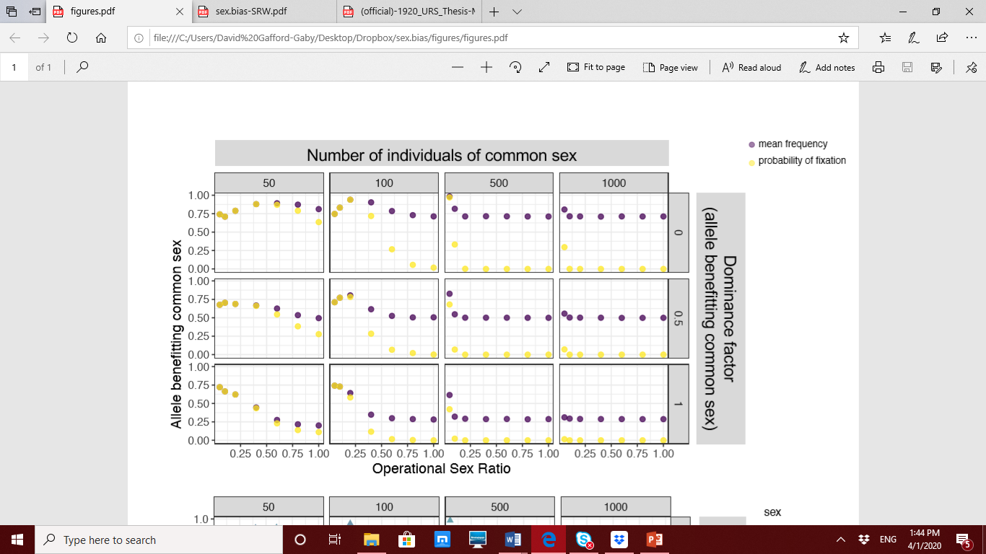

Figure 1: Impact of variation in operational sex ratio on genetic variation. Columns indicate number of individuals of the common sex, while rows indicate the dominance factor. The x-axis represents the operational sex ratio. The y-axis represents either the mean frequency of the allele benefitting the common sex (yellow) or the probability of that allele fixing (purple).

Reducing the common sex population size to 50 individuals allowed genetic drift to predominate, and a high degree of fixation was observed even with equal numbers of both sexes participating in reproduction. With an OSR of 1.0 and an additive genetic architecture, one of the two alleles fixed in 25% of the simulations. However, under a similar scenario but with a recessive common sex benefiting allele, that allele fixed nearly 60% of the time. Likewise, when this scenario was set with the allele benefitting the common sex displaying a dominant genetic architecture, the rare sex beneficial allele fixed in 60% of the simulations. This latter scenario is the only parameter set that consistently resulted in an overall higher degree of fitness for the rare sex. Despite this, we would expect that an equal number of mutations in the dominant genetic architecture would balance this, resulting in a no net gain in fitness for the rare sex. Furthermore, scenarios with these conditions but with an OSR reduced below 1.0 begin to display bias for fixing allele benefitting the common sex once again.

There is no evidence or reason to believe that genetic architecture biases whether mutations are beneficial to one sex or the other, so we can safely marginalize across genetic architectures to analyze the mean difference between common sex and rare sex fitness. From this, we show that when the common sex population is small (either 50 or 100 individuals), unequal OSR values, or those less than 1.0, lead to a decrease in the rare sex’s fitness relative to the common sex, with the most extreme fitness collapse occurring with an OSR of 0.2. However, larger common sex population sizes require a higher OSR level (0.05-0.10) to achieve a similar relative collapse of the rare sex fitness, though in these scenarios the relative fitness collapse is most dramatic.

Though our results are designed for an autosomal locus in an XY sex determination system, they are also valid for autosomal loci in ZW sex determination systems and any loci in environmental sex determination systems. The latter is of increasing relevance as climate change could produce consistent strong biases in sex ratio in organisms with temperature based environmental sex determination, which in turn could put such populations at risk for rare sex fitness collapse.

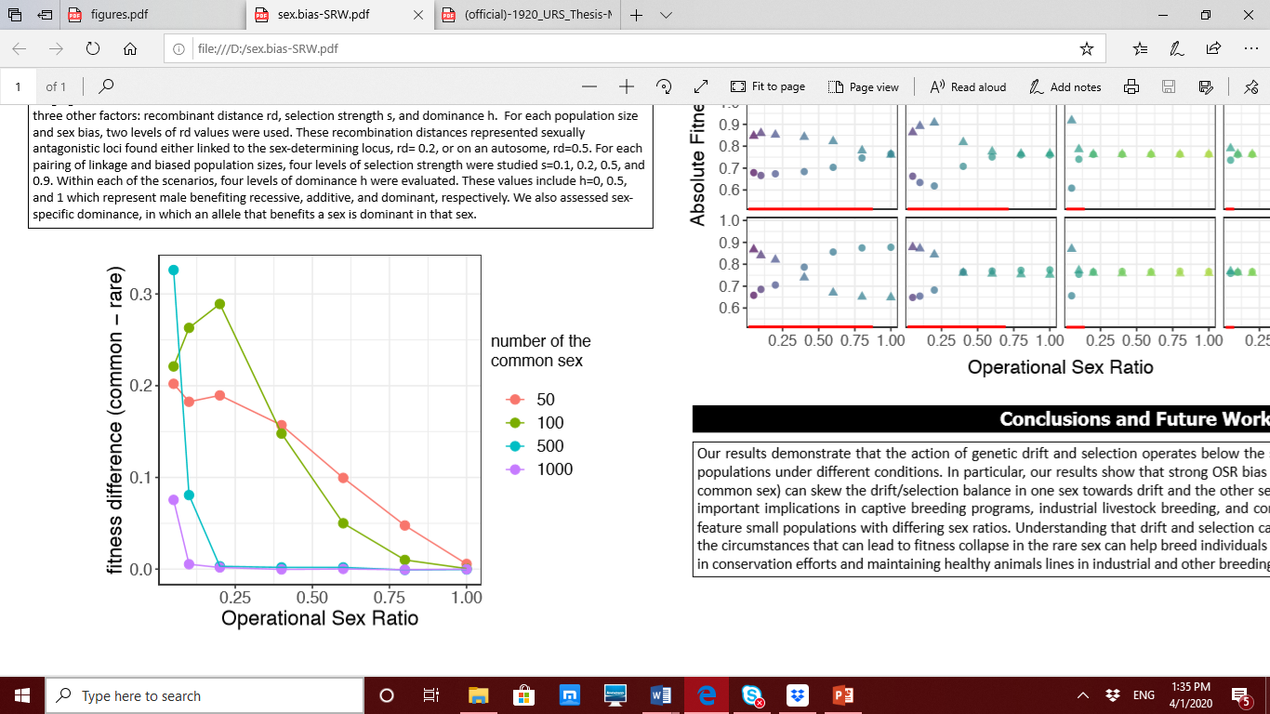

Figure 2: Fitness divergence among sexes. The y-axis represents the difference between the absolute fitness of the common sex and that of the rare sex. The x-axis represents the operational sex ratio. The color of the line represents the number of the common sex. Higher values on the vertical axis indicate increased fitness for the common sex and reduced fitness for the rare sex.

Chapter IV

Conclusion

Our results demonstrate that the action of genetic drift and selection operates below the species level and can work within sexes in given populations under different conditions. In particular, our results show that strong OSR bias and small population size (100 individuals in the common sex) can skew the drift/selection balance in one sex towards drift and the other sex towards selection. This information could have important implications in captive breeding programs, industrial livestock breeding, and conservation efforts, as these programs frequently feature small populations with differing sex ratios. Understanding that drift and selection can work within sexes of populations and knowing the circumstances that can lead to fitness collapse in the rare sex can help breed individuals that retain alleles beneficial to both sexes, aiding in conservation efforts and maintaining healthy animal lines in industrial and other breeding.

References

Allendorf, F. W., 1986 Genetic drift and the loss of alleles versus heterozygosity. Zoo biology 5**:** 181-190.

Andrews, C., 2010 Natural Selection. Genetic Drift and Gene Flow do Not Act in Isolation in Natural Populations. Nature Education Knowledge 3**:** 5.

Elmberg, J., 1990 Long-term survival, length of breeding season, and operational sex ratio in a boreal population of common frogs, Rana temporaria L. Canadian Journal of Zoology 68**:** 121-127.

Foerster, K., T. Coulson, B. C. Sheldon, J. M. Pemberton, T. H. Clutton-Brock *et al.*, 2007 Sexually antagonistic genetic variation for fitness in red deer. Nature 447**:** 1107-1110.

Frankham, R., 1996 Relationship of genetic variation to population size in wildlife. Conservation biology 10**:** 1500-1508.

Gerke, J. P., J. W. Edwards, K. E. Guill, J. Ross-Ibarra and M. D. McMullen, 2015 The genomic impacts of drift and selection for hybrid performance in maize. Genetics 201**:** 1201-1211.

Gwynne, D. T., 1990 Testing parental investment and the control of sexual selection in katydids: the operational sex ratio. The American Naturalist 136**:** 474-484.

Innocenti, P., and E. H. Morrow, 2010 The sexually antagonistic genes of Drosophila melanogaster. PLoS biology 8.

Jirotkul, M., 1999 Operational sex ratio influences female preference and male–male competition in guppies. Animal Behaviour 58**:** 287-294.

Lacy, R. C., 1997 Importance of genetic variation to the viability of mammalian populations. Journal of Mammalogy 78**:** 320-335.

Lande, R., 1976 Natural selection and random genetic drift in phenotypic evolution. Evolution 30**:** 314-334.

Lande, R., and G. Barrowdough, 1987 Effective population size, genetic variation, and their use in population. Viable populations for conservation**:** 87.

Mitani, J. C., J. Gros-Louis and A. F. Richards, 1996 Sexual dimorphism, the operational sex ratio, and the intensity of male competition in polygynous primates. The American Naturalist 147**:** 966-980.

Perrier, C., A. L. Ferchaud, P. Sirois, I. Thibault and L. Bernatchez, 2017 Do genetic drift and accumulation of deleterious mutations preclude adaptation? Empirical investigation using RAD seq in a northern lacustrine fish. Molecular ecology 26**:** 6317-6335.

Appendix (THIS PAGE IS optional)